Make a Search tree for below given problem

Apply BFS & DFS Algorithm Compute the Pathway and Pathcost

And suggest which search technique is suitable for this problem

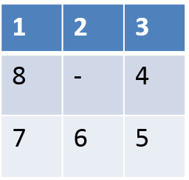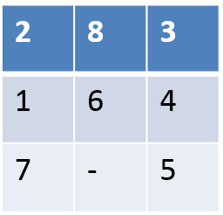

Goal State

Initial State

State: The location of the eight tiles, and the blank

Initial State: {(2,0), (8,1), (3,2),

(1,3), (6,4), (4,5), (7,6), (-,7), (5,8)}

Successor Function: four actions (blank moves Left, Right, Up, Down).

Goal Test: determine a given state is a goal state.

Path Cost: each step costs 1

Solution: {(1,0),(2,1),(3,2) ,(8,3) ,(-,4) ,(4,5) ,(7,6) ,(6,7)

,(5,8)}